**DAILY ONLINE ACTIVITIES SUMMARY**

|  |  |  |  |  |  |  |  |  |
| --- | --- | --- | --- | --- | --- | --- | --- | --- |
| **Date:** | **1/06/2020** | | | | | **Name:** | **POOJA D S** | |
| **Sem & Sec** | **4th SEM 'B' Section** | | | | | **USN:** | **4AL18CS056** | |
| **Online Test Summary** | | | | | | | | |
| **Subject** | | **Complex Analysis, Probability and Statistical Method** | | | | | | |
| **Max. Marks** | | **30** | | **Score** | | | **25** | |
| **Certification Course Summary** | | | | | | | | |
| **Course** | **Computer Vision Essentials** | | | | | | | |
| **Certificate Provider** | | | **Great Learning Academy** | | **Duration** | | | **5.5 hour** |
| **Coding Challenges** | | | | | | | | |
| **Problem Statement:** A user will input two strings, and we find if one of the strings is a sub sequence of the other. Program prints “yes” if either the first string is a sub sequence of the second string or the second string is a sub sequence of the first string. Assume that, the length of the first string is smaller than or equal to the length of the second string. Assume that, the length of the first string is smaller than or equal to the length of the second string. | | | | | | | | |
| **Status: completed** | | | | | | | | |
| **Uploaded the report in Github** | | | | | **yes** | | | |
| **If yes Repository name** | | | | | <https://github.com/dspooja/Java-coding>  <https://github.com/dspooja/C-coding> | | | |
| **Uploaded the report in slack** | | | | | **yes** | | | |

Online Test Details: (Attach the snapshot and briefly write the report for the same)

Certification Course Details: (Attach the snapshot and briefly write the report for the same)

Coding Challenges Details: (Attach the snapshot and briefly write the report for the same)

ONLINE TEST DETAILS:

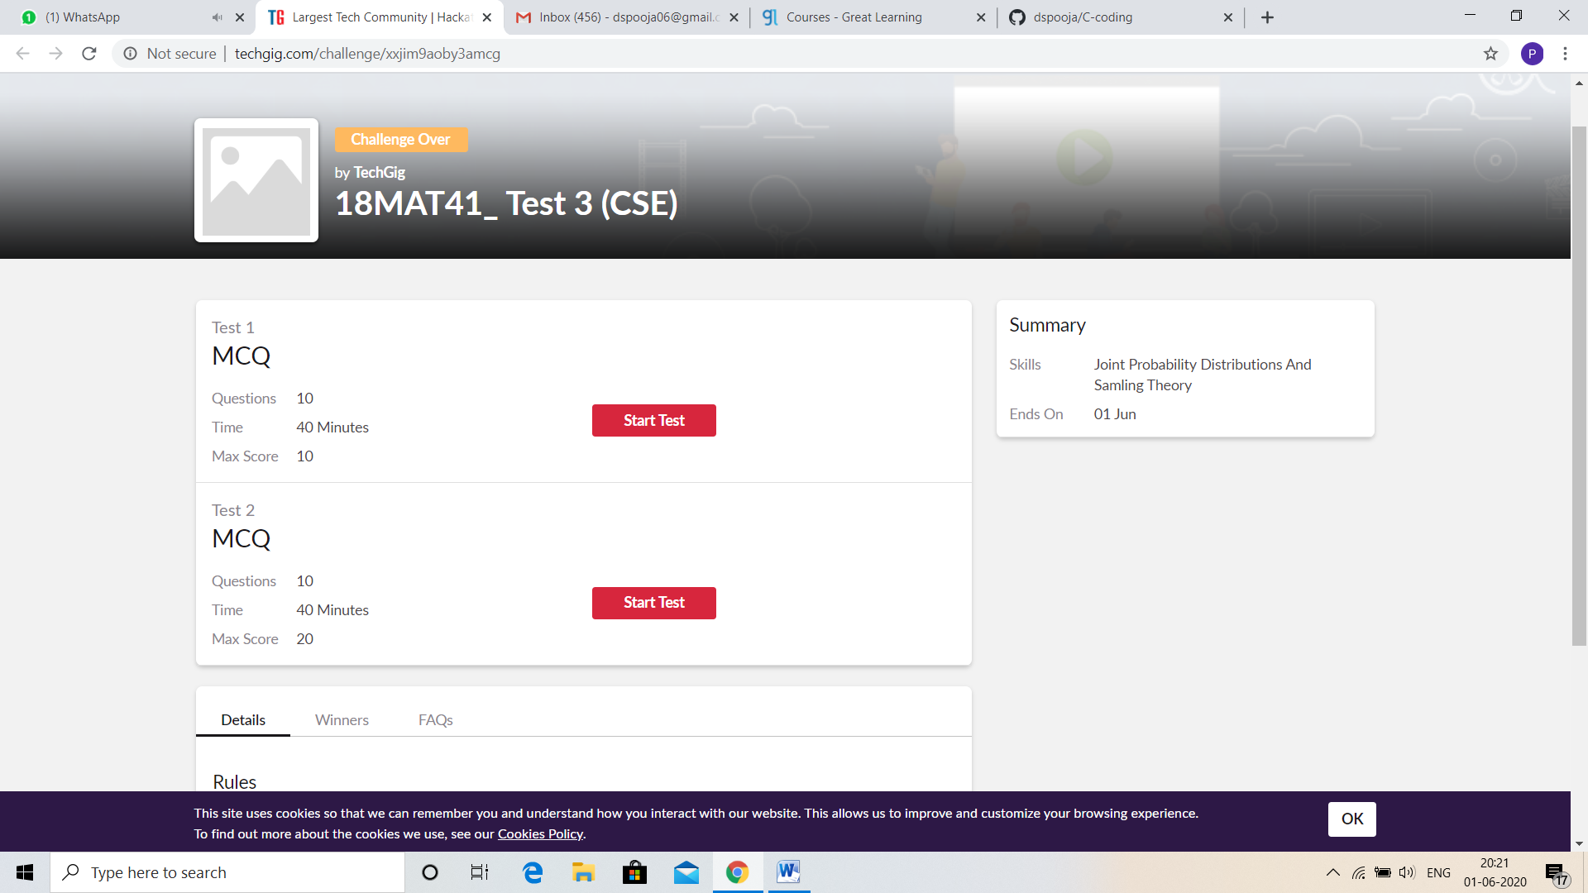

CERTIFICATION COURSE DETAILS:

* As continuation of the **Computer Vision Essentials** online course
* **The concepts covered in Computer Vision Essentials are:**
* Working with Image - Introduction
* Working with Images – Digitization, Sampling and Quantization
* Working with Images - Filtering
* Hands – on Python Demo: Working with Images.ipynb

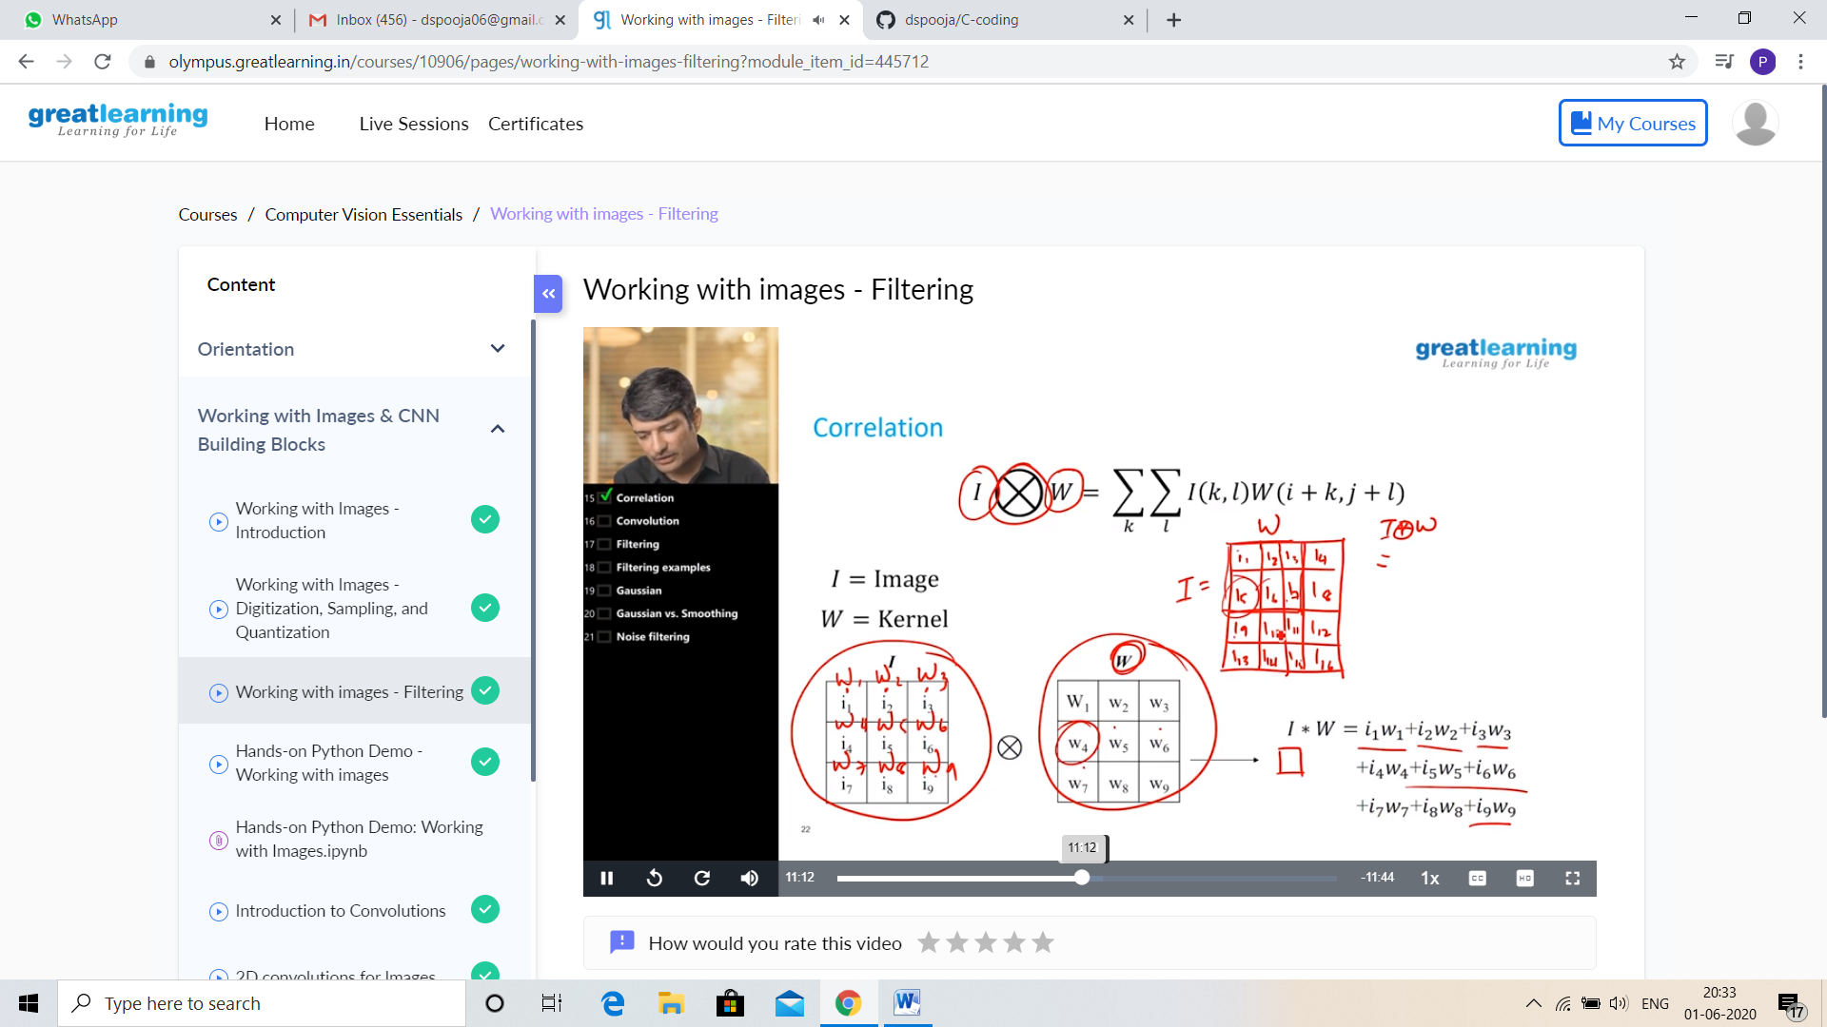

CODING CHALLENGES DETAILS:

Problem statement 1:

Given an array arr[] of size N and an integer K. The task is to find the count of subarrays such that each subarray has exactly K distinct elements.

Examples: Input: arr[] = {2, 1, 2, 1, 6}, K = 2 Output: 7 {2, 1}, {1, 2}, {2, 1}, {1, 6}, {2, 1, 2}, {1, 2, 1} and {2, 1, 2, 1} are the only valid subarrays

Solution : Uploaded it in github

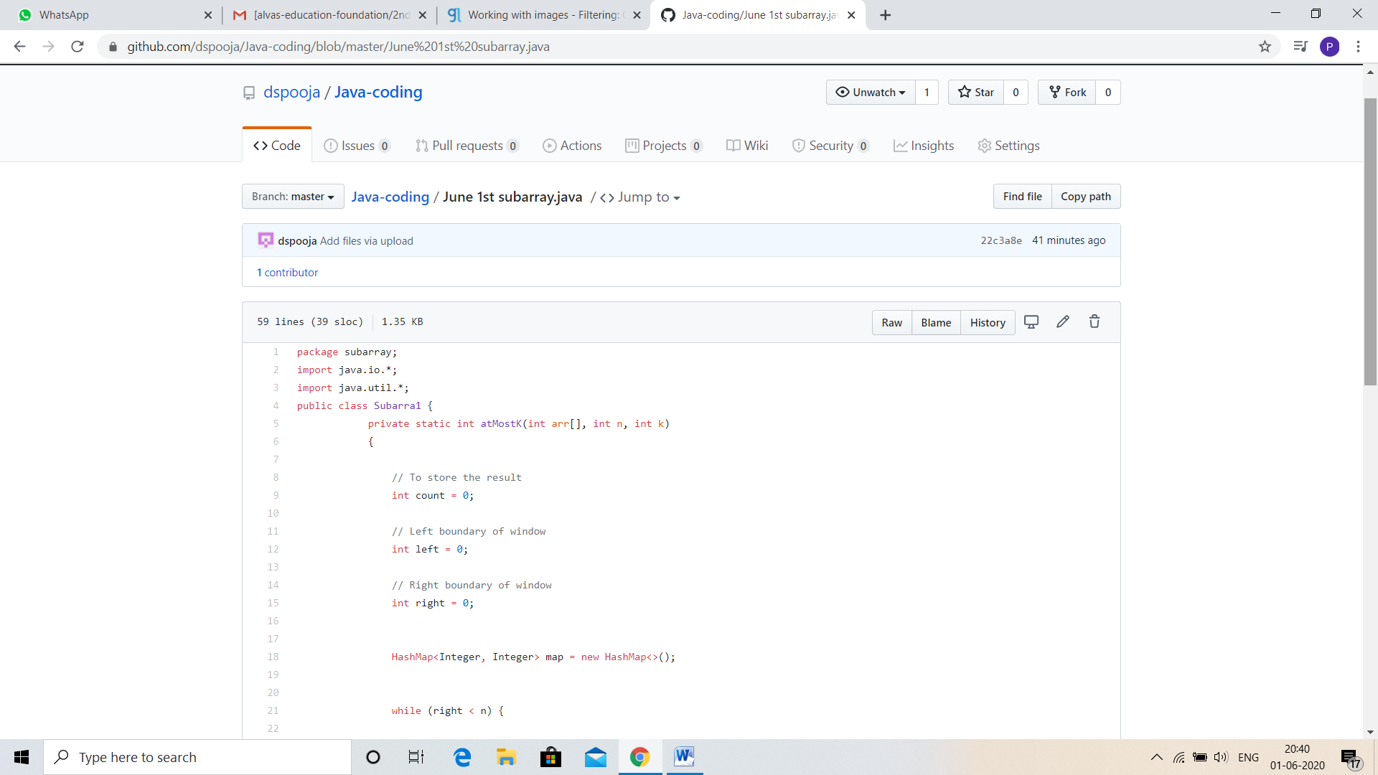

Problem statement 2:

java program

Define a class Point with two fields x and y each of type double. Also , define a method distance(Point p1, Point p2) to calculate the distance between points p1 and p2 and return the value in double. Use Math.sqrt( ) to calculate the square root.

Solution: Uploaded in github.

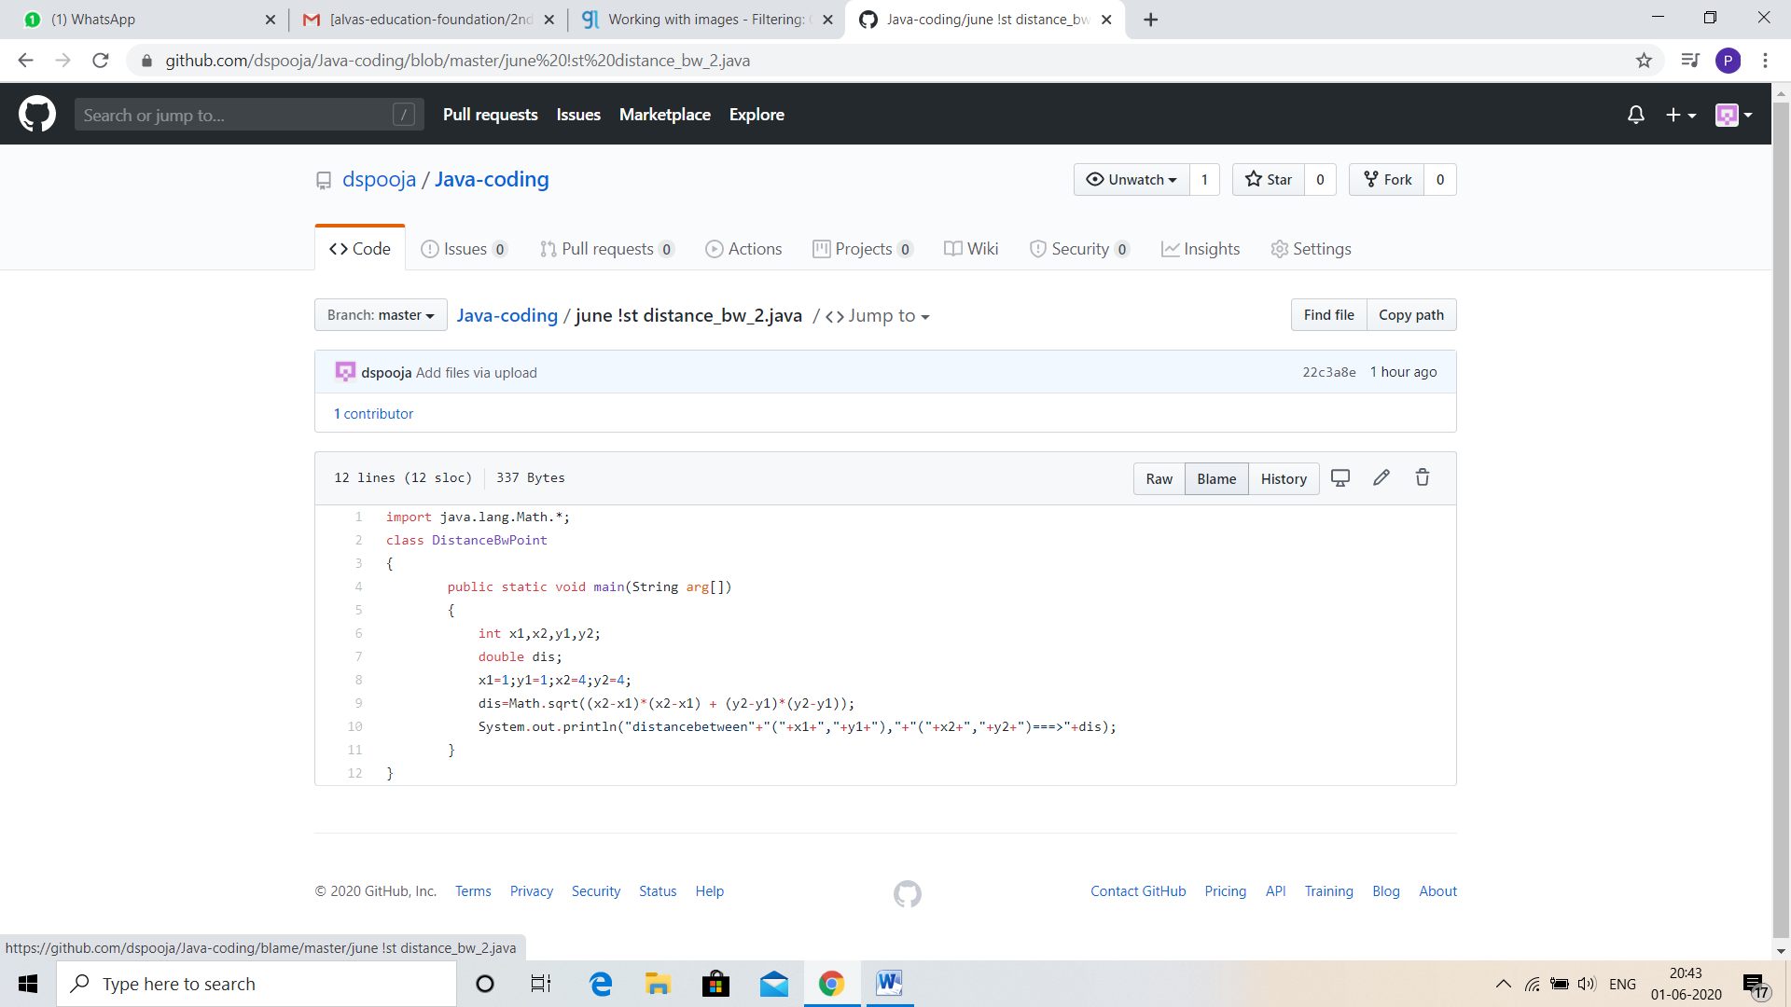

Problem statement 3:

Given an array of positive integers. Write a C Program to find the leaders in the array.

**Note:** An element of array is leader if it is greater than or equal to all the elements to its right side. Also, the rightmost element is always a leader.

**Input:**  
The first line of input contains an integer T denoting the number of test cases. The description of T test cases follows.  
The first line of each test case contains a single integer N denoting the size of array.  
The second line contains N space-separated integers A1, A2, ..., AN denoting the elements of the array.

**Output:**  
Print all the leaders.

**Constraints:**  
1 <= T <= 100  
1 <= N <= 107  
0 <= Ai <= 107

**Example:**

**Input:**   
3  
6  
16 17 4 3 5 2  
5  
1 2 3 4 0  
5  
7 4 5 7 3

**Output:**   
17 5 2  
4 0  
7 7 3  
**Explanation:  
Testcase 3:** All elements on the right of 7 (at index 0) are smaller than or equal to 7. Also, all the elements of right side of 7 (at index 3) are smaller than 7. And, the last element 3 is itself a leader since no elements are on its right.

Solution: Uploaded in github.

